Jenkins Setup in Azure Vm

1)Create Resource group

2)Create Azure virtual machine

3)Install Jenkins in Azure Vm( start with basic level configuration later you can increase the size according the jenkins pipeline usage)

Jenkins on Ubuntu 22.04

Installation steps : Run the below command by connecting to azure Vm using ssh/powershell

1. wget -q -O - <https://pkg.jenkins.io/debian-stable/jenkins.io.key> |sudo gpg --dearmor -o /usr/share/keyrings/jenkins.gpg
2. sudo sh -c 'echo deb [signed-by=/usr/share/keyrings/jenkins.gpg] <http://pkg.jenkins.io/debian-stable> binary/ > /etc/apt/sources.list.d/jenkins.list'
3. sudo apt update
4. sudo apt install jenkins
5. sudo apt install openjdk-11-jdk
6. sudo systemctl start jenkins.service
7. sudo systemctl status jenkins

If everything went well, the beginning of the status output shows that the service is active and configured to start at boot.

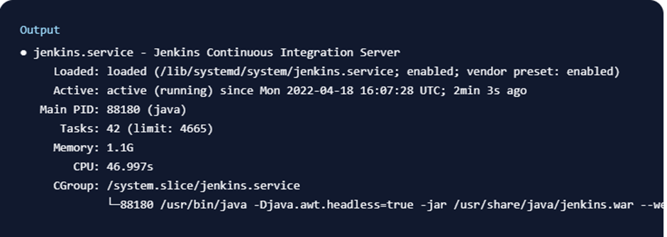

Refer the documents:

1. <https://www.digitalocean.com/community/tutorials/how-to-install-jenkins-on-ubuntu-22-04>
2. <https://www.cherryservers.com/blog/how-to-install-jenkins-on-ubuntu-22-04>

Setting Up Jenkins

By default Jenkins will open on 8080 port

**In Azure Vm where Jenkins is installed , open network settings and open 8080 port in inbound port rules,**

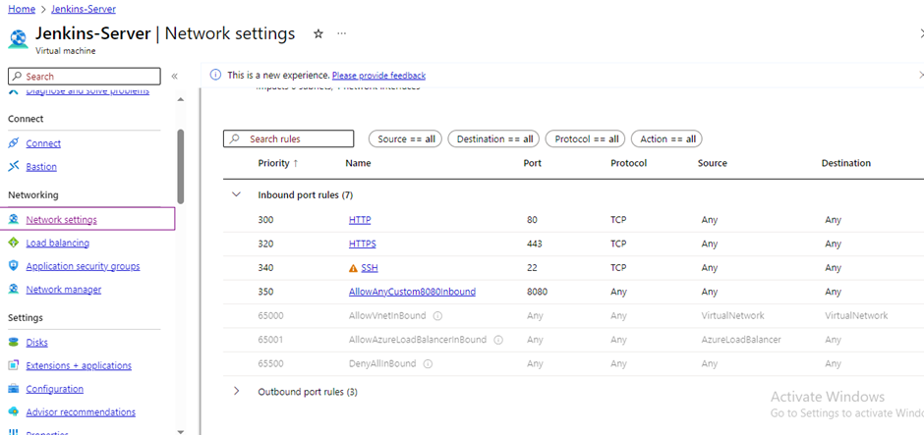

**Open Jenkins with the ipaddress of Azure Vm with 8080 port**

<http://20.24.48.196:8080/>

Unlock Jenkins screen, which displays the location of the initial password:

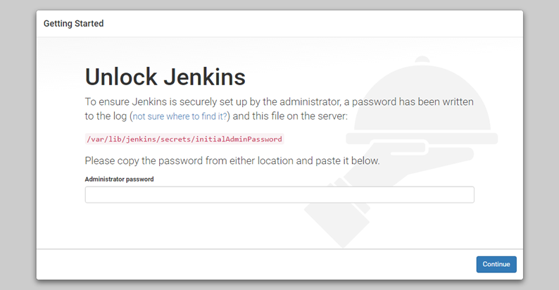

Type the command in powershell/ssh that should be connected to jenkins azure vm

**sudo cat /var/lib/jenkins/secrets/initialAdminPassword**

Copy the 32-character alphanumeric password from the terminal and paste it into the Administrator password field, then click Continue.

The next screen presents the option of installing suggested plugins or selecting specific plugins:

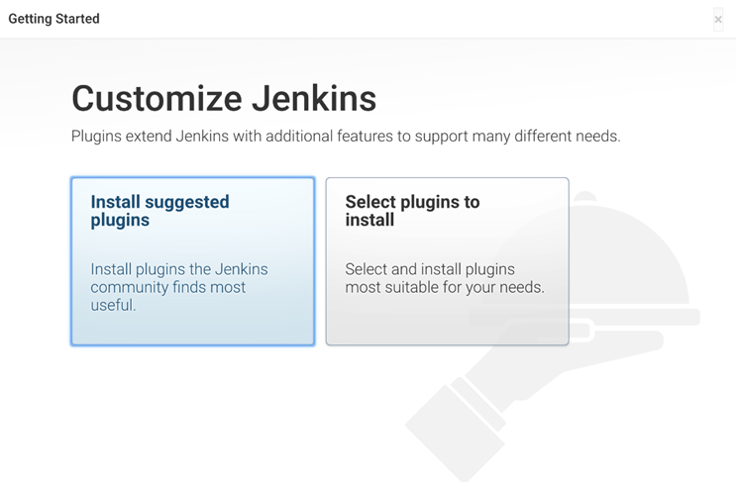

Install suggested plugins option

Enter the name and password for the setup

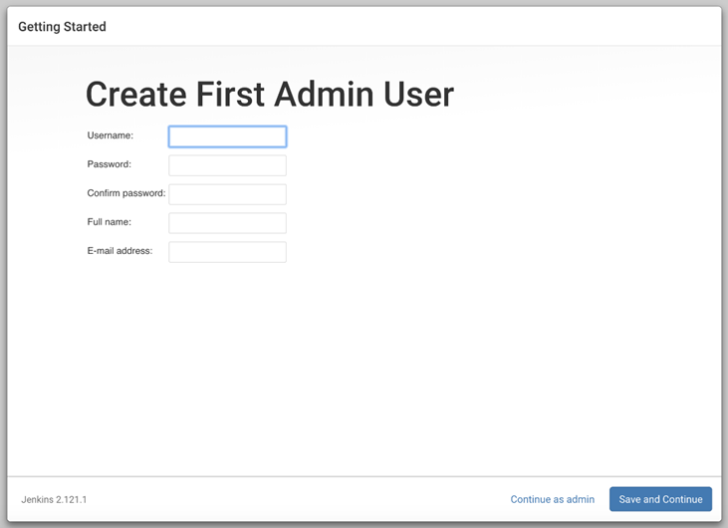

username: Jenkins_server

password: [Jenkins@654321](mailto:Jenkins@654321)

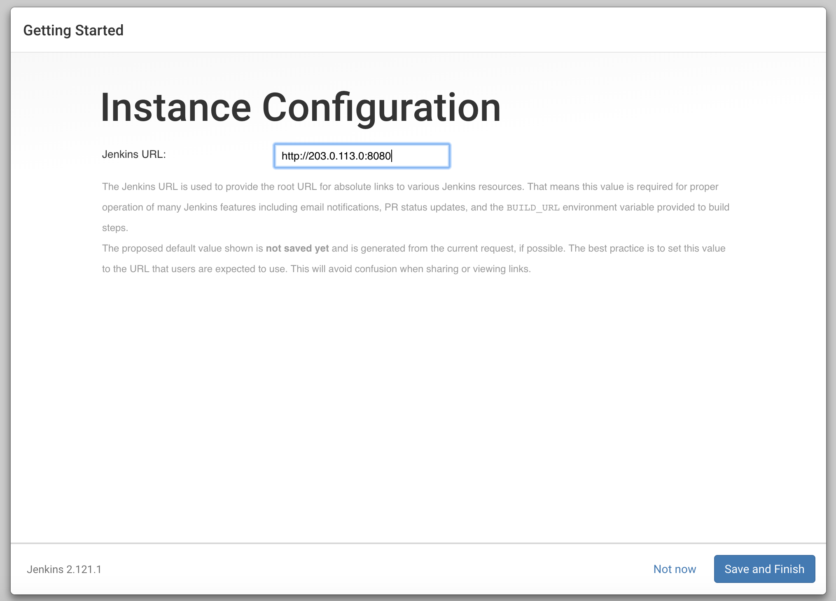

Click Save and finish

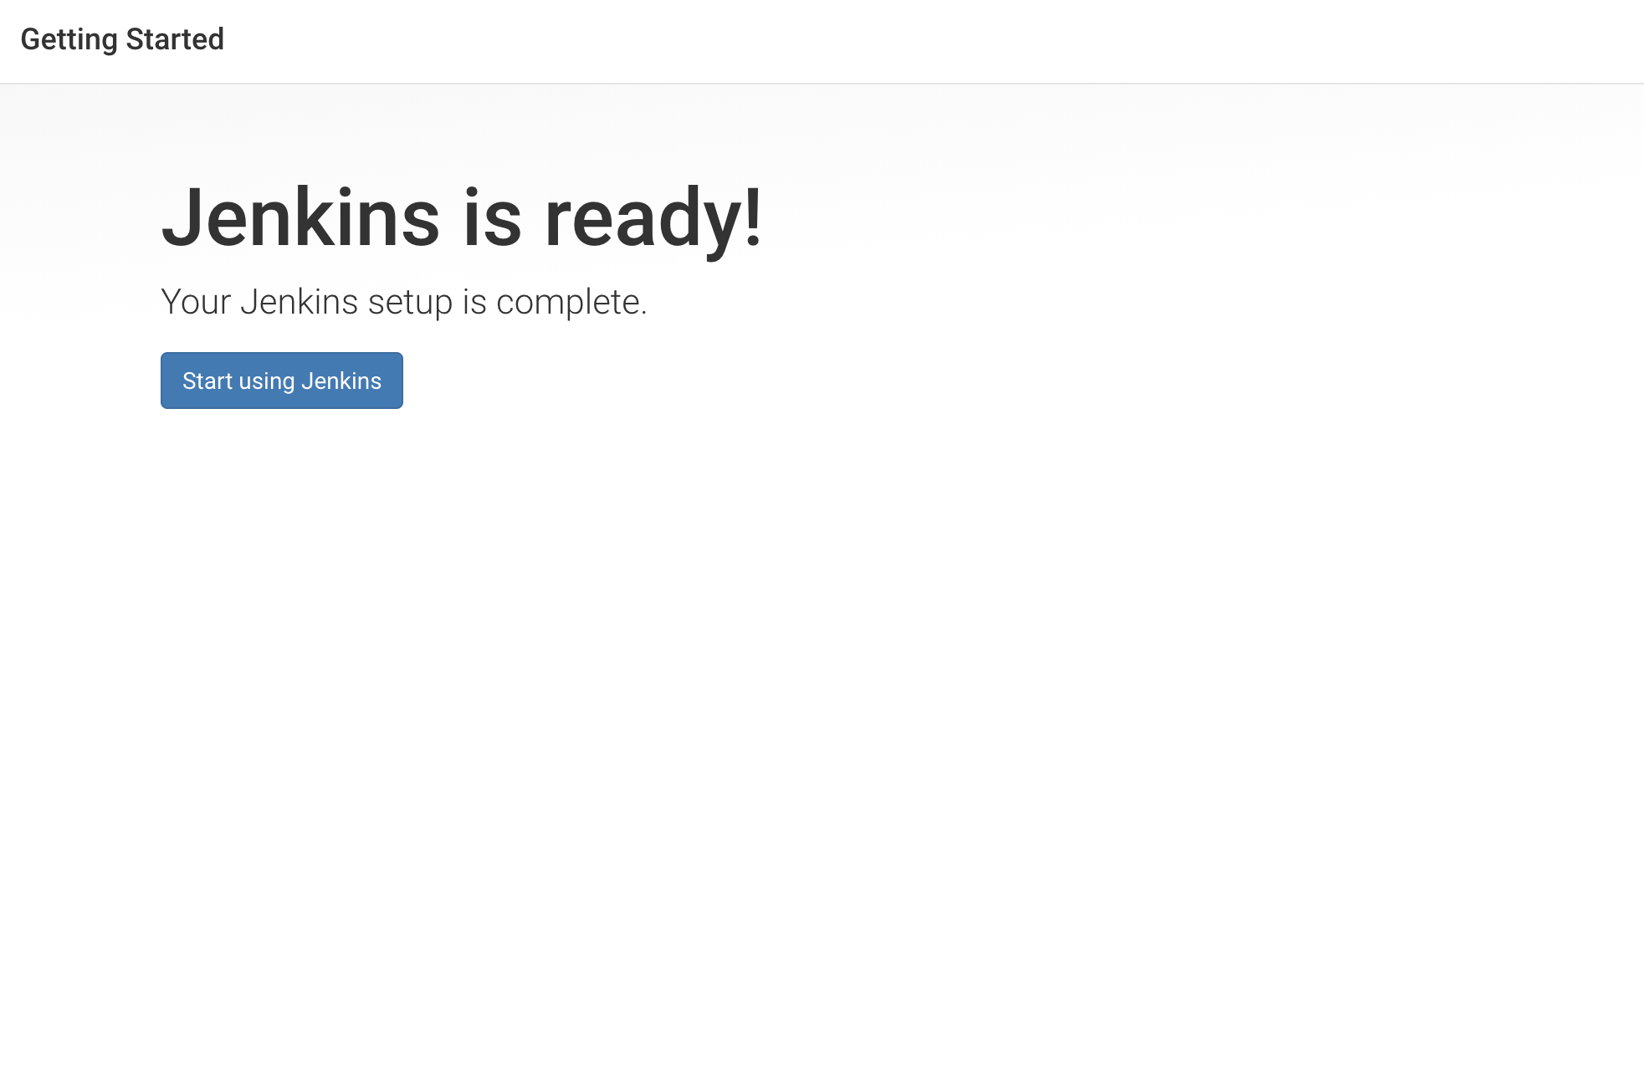

Click Start using jenkins

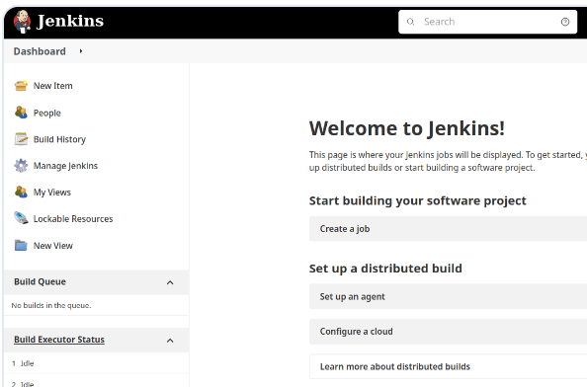

Jenkins Dashboard will be opened

Install necessary plugins for jenkins to connect with Azure Repos and Azure portal

1)Azure App Service PluginVersion

2)Azure CLI PluginVersion

3)Azure Container Registry Tasks PluginVersion

4)Azure Credentials

5)Credentials Plugin

6)Mask Passwords Plugin

7)Microsoft Entra ID (previously Azure AD)

8)VS Team Services Continuous Deployment

**Setting up Jenkins pipeline**

**Click on newitem**

**Give the name to the pipeline**

**Select the pipeline type:Pipeline**

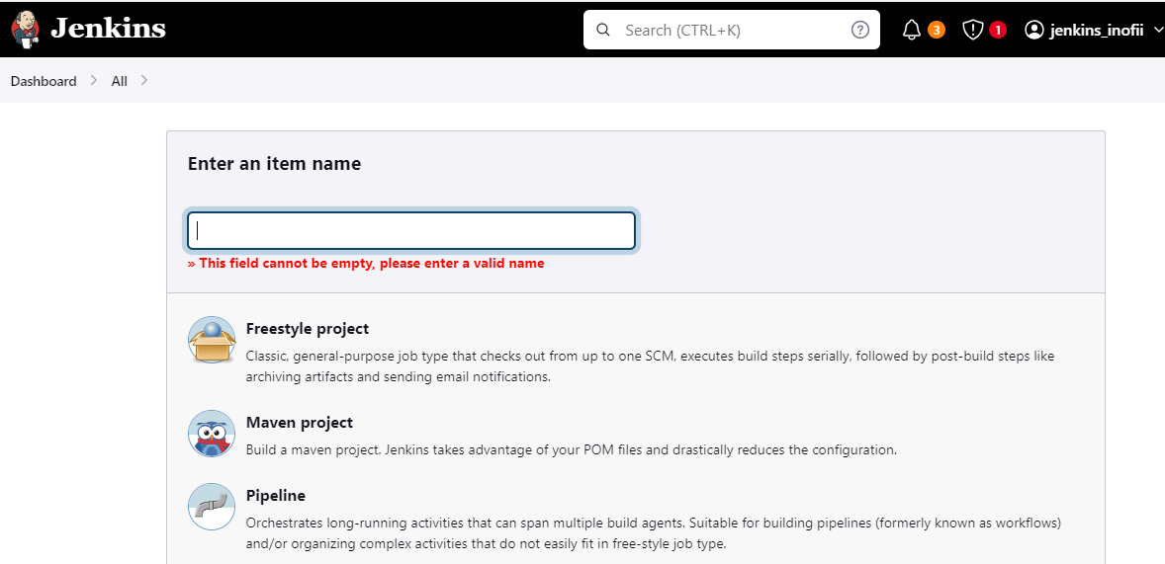

Click Ok

Then we will get configuration page

Where we need to configure the pipeline

Select Pipeline Script from Scm

In SCM :select Git

Give AZure repos url

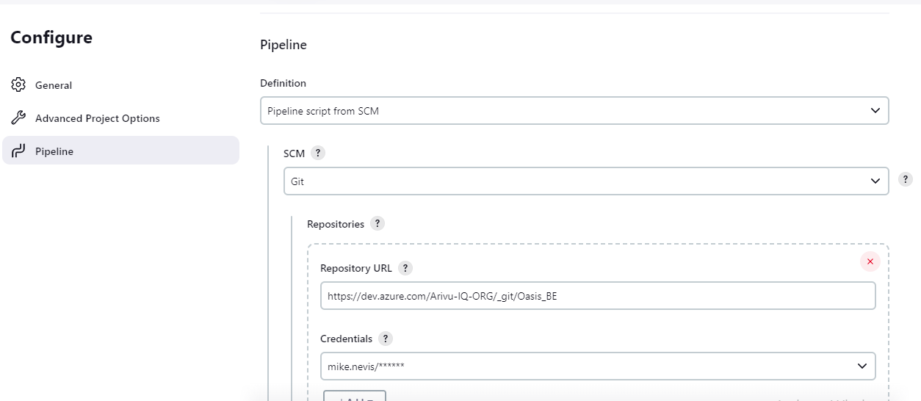

Credentials : Click ADD

**You will find jenkins icon Click Jenkins icon And add PAT credentials**

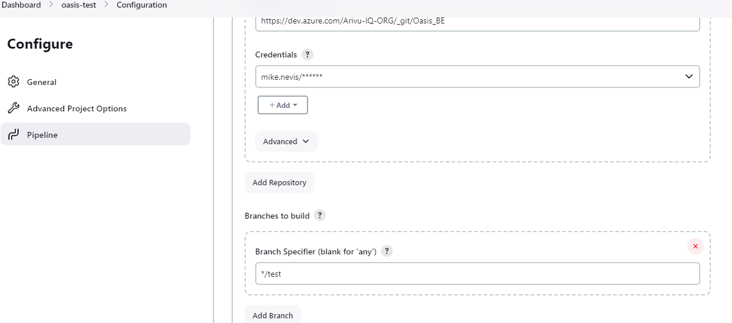

SELECT Target branch

You need to have the jenkinsfile in the azure repos target branch

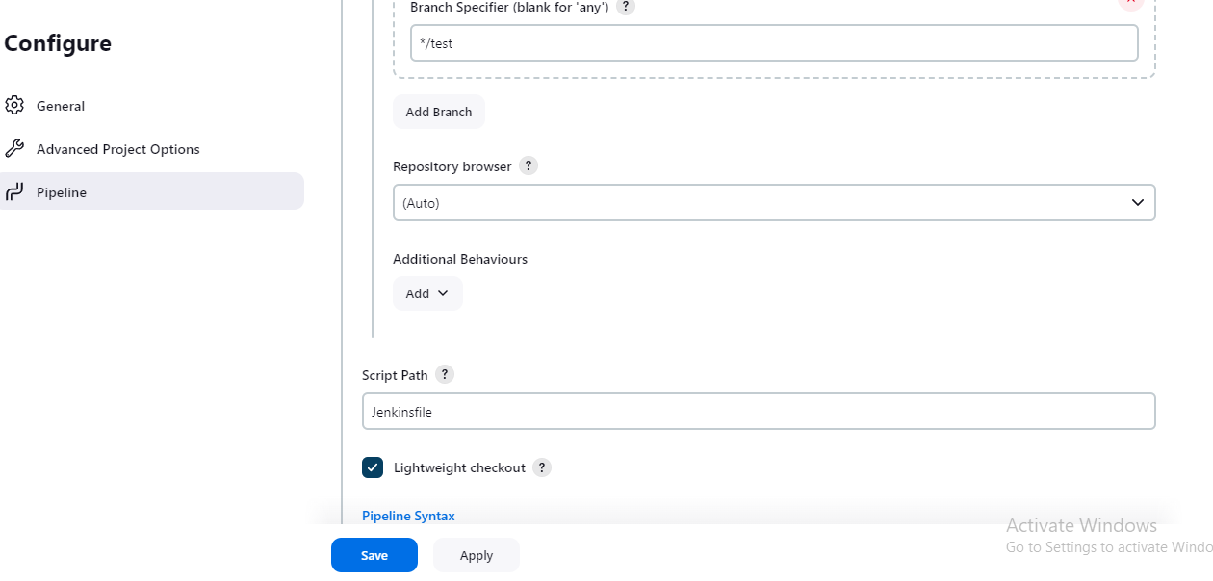The jenkins file script is build the docker image ,pushing the docker image to ACR and deploying the Docker image to Azure webapp

Change the jenkinsfile according to the rquirement

For jenkins to access the azure portal you need to provide azure poratl credentials in jenkins

For that reason we need to create app registration in Azure portal

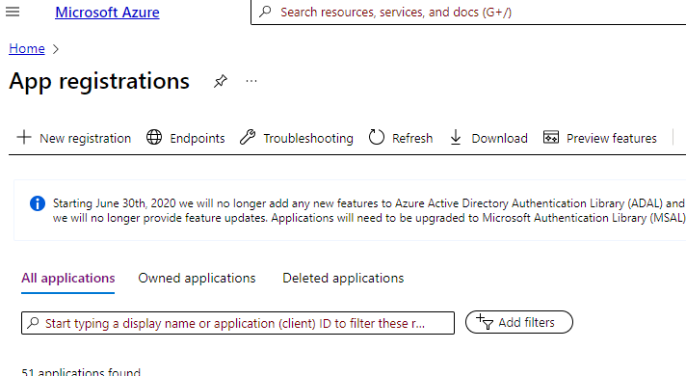**Click new registrations**

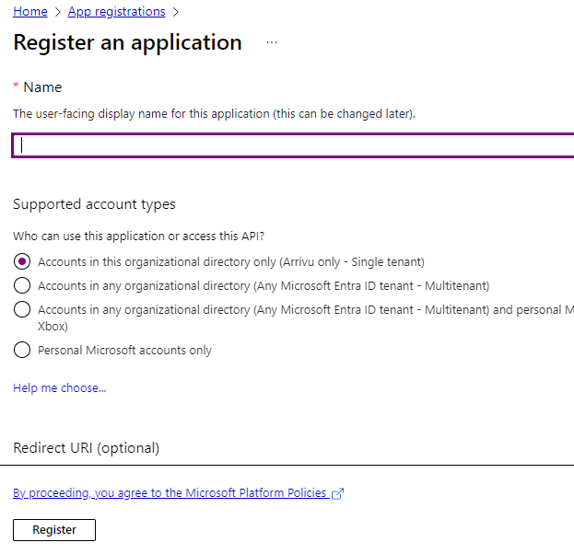

Give the name and click on register

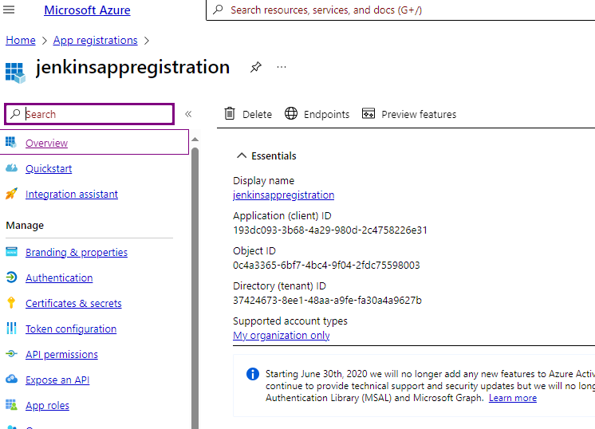

Note CLient ID,Tenant ID

Next go to **certifications and Secrets**

**Create new secret client and note the secret client value (it will not show after sometime so note it)**

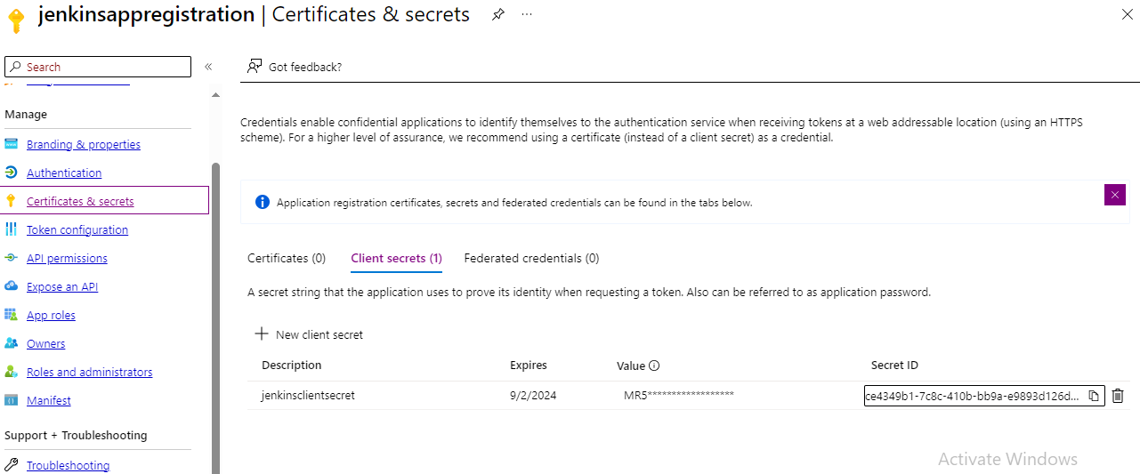

With Client ID,Tenant ID, Secret Id, and you need to know the Type of Azure Subscription and Subscription ID

Create Service connection in Azure Devops

Go to project settings and service connections

Give the above details and create service connection for jenkins

Select Service connection

Select **New Service Connection**

**Select Jenkins**

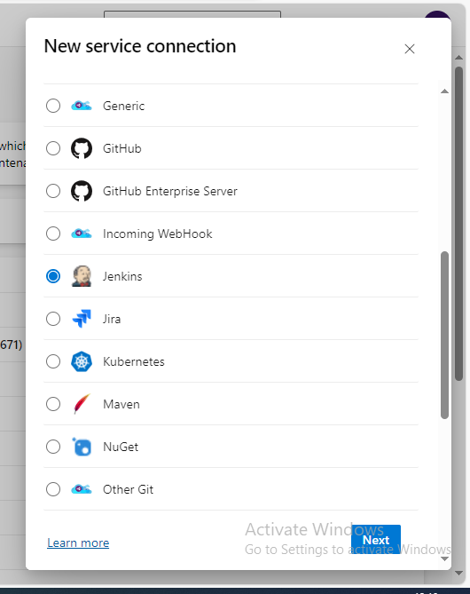

Click next

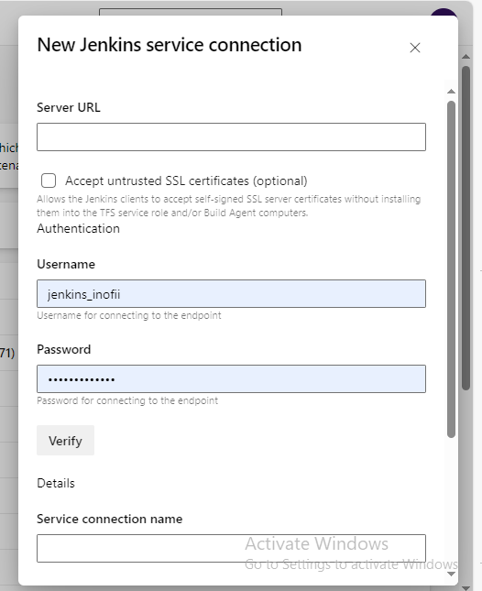

GIve jenkins server url

Username and password of jenkins

Give service connection name

**Save**

**In jenkins dashboard**

**Goto Manage jenkins**

**Go to credentials**

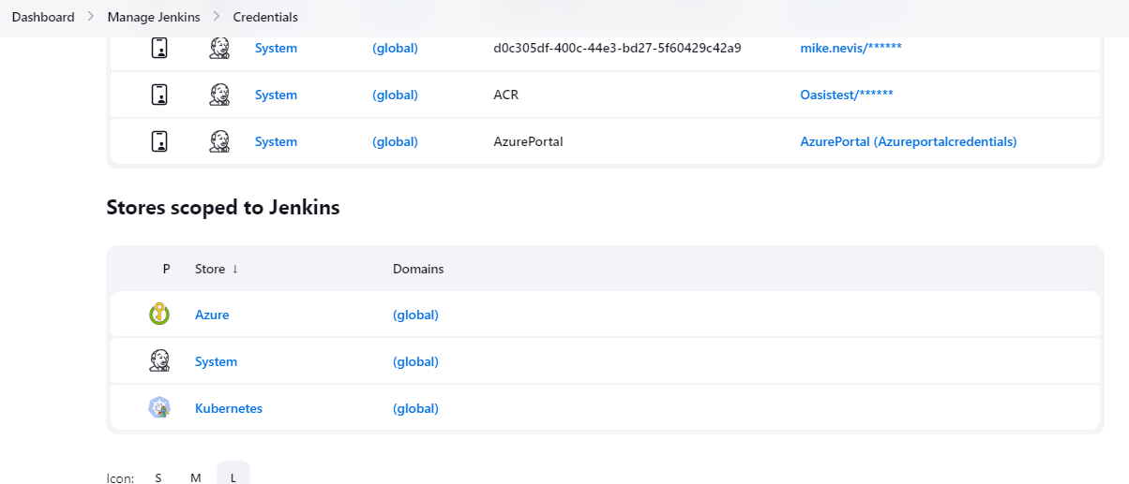

Go to System

Go to Global credentials

Add credentials

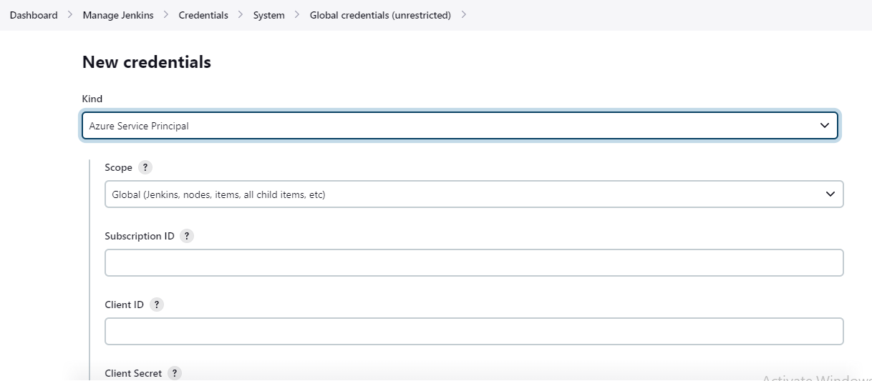Select Azure Service Principle

Give the details of Subscription id ,client id, client secret id, tenant id ,

Give ID and description(optional) to know what credentials give are saving

**We need give contributor role for app registration which we have created for jenkins in azure portal**

Then run the pipeline by clicking **Buildnow** in jenkins dashboard

To automatically run jenkins pipeline when code is pushed to azure repos ,we need to add service hook in azure devops

Go to project settings

Select Service hooks

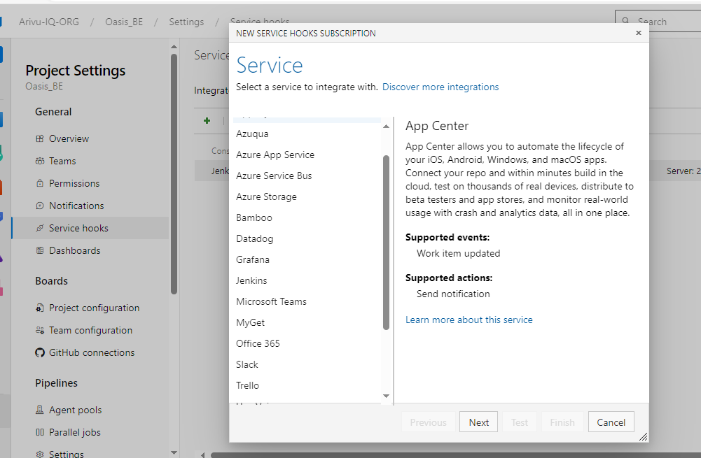

Select Jenkins

Click next

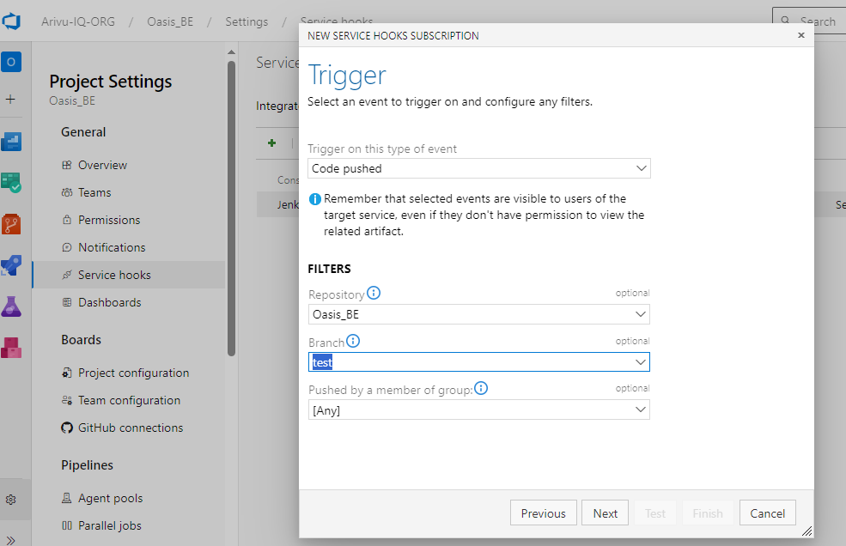Select the necessary repository and branch

Click next

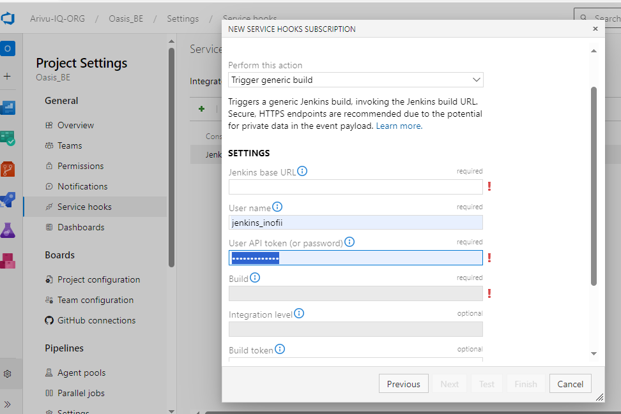 give the details jenkins base url,username,(password or API token which can be genereted in jenkins dashboard configure)

Click finish